EXPERIMENT-10

ROLL NO: 240701238 NAME: Kathir Vikaas S

Create a data visualization (e.g., pie charts, bar graphs) for a Student Performance Dashboard using javascript

AIM:
To create data visualizations such as pie charts and bar graphs for a Student Performance Dashboard using JavaScript.

PROCEDURE:
Step 1: Create HTML File
- Create an HTML page
- Add heading “Student Performance Dashboard” ● Add two canvas elements:
  - Pie Chart
○ Bar Chart
- Include Chart.js library

Step 2: Create JavaScript File
- Create script.js file ● Define inventory data:
  - Electronics
○ Clothing
○ Home Appliances
○ Books
○ Toys
- Use Chart.js to create:
  - Pie chart for distribution
○ Bar graph for stock comparison

CODE:
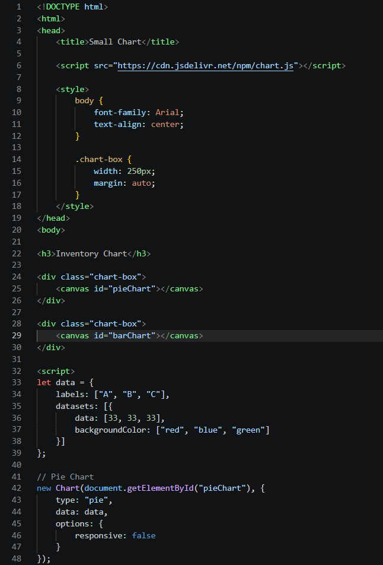
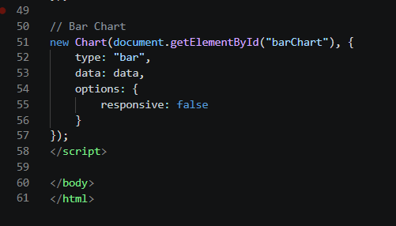

OUTPUT

